KITCHEN VISION

Team ID: SWTID-2026-8166
Team Members:
Team Leader: Dhanalakshmi M
Team Member 1: Poornima R
Team Member 2: Swetha P
Team Member 3: Anusha Valli B

PROJECT DESCRIPTION:

Kitchen Vision is an intelligent cooking assistance application built using Python and the Streamlit framework. It helps users identify ingredients in their pantry and generate simple recipes using artificial intelligence and computer vision techniques. The system allows users to upload an image of their pantry. The image is pre-processed using techniques like resizing and contrast enhancement to improve detection accuracy. A vision-based AI model then analyzes the image and identifies the available food items, which are automatically categorized into storage types such as Dry Storage, Cold Storage, Frozen, and Fresh Produce.
Based on the detected ingredients, the system generates three beginner-friendly recipes with a list of ingredients, short three-step cooking instructions, estimated preparation time, and difficulty level. If any ingredients are missing, the system creates a grocery list and suggests ingredient substitutes.
Additionally, Kitchen Vision includes a health evaluation module that assigns a nutritional score (1–10) to each recipe based on factors such as calories, protein, fiber, and fat levels.Overall, the project demonstrates how AI, computer vision, and web-based interfaces can be combined to simplify meal planning, reduce food waste, and promote healthier eating habits.

USE CASE SCENARIAS

Scenario 1: Pantry Image Analysis and Item Detection
Users open the Kitchen Vision application and upload an image of their open pantry. The AI-powered vision module then analyses the image and identifies visible food items.

Scenario 2: Item Categorization and Storage Classification
Once the ingredients are detected, the system automatically categorizes them based on storage type. Items are grouped into categories such as Dry Storage, Cold Storage, Frozen, and Fresh Produced.

Scenario 3: Smart Recipe Generation with Health Scoring
At the same time, the Health Service evaluates the nutritional value of each recipe and assigns a score from 1 to 10 along with a short explanation.

Scenario 4: Grocery List Creation and Missing Ingredient Identification
The system compares the ingredients required for each recipe with the items detected in the pantry.

Scenario 5: Ingredient Substitution Recommendation
To improve flexibility, the system also suggests suitable substitutes for missing ingredients using a built-in substitution knowledge base.

Scenario 6: Consolidated Cooking Guidance Output
Finally, the application presents all results—including detected ingredients, storage categories, generated recipes, health scores, grocery lists, and substitution suggestions—in a clean and well- structured interface
ARCHITECTURE OVERVIEW

Kitchen Vision is an intelligent and modular application that analyzes pantry images to generate smart cooking recommendations. The system combines a Streamlit -based user interface with an AI-powered vision and reasoning layer that processes pantry images and converts them into structured cooking insights. The architecture follows a service-oriented modular design, separating image processing, item detection, recipe generation, substitution logic, and health evaluation into independent modules. This structure improves scalability,
maintainability, and system flexibility. The platform also supports both mock AI models and real multimodal AI models, such as Gemini Vision or OpenAI Vision, allowing developers to easily switch between models depending on the deployment requirements.

CORE TECHNOLOGIES
- Streamlit provides the frontend interface for user interaction and result visualization.
- Python backend logic and AI services are implemented.
- Pillow (PIL ):For image preprocessing and enhancement, the system uses the library.
- Multimodal AI models such as Gemini Vision or OpenAI Vision.
- Python-dotenv for secure configuration management
- Docker for containerized deployment and environment consistency.

Component | Description
Frontend UI (Streamlit) | Provides an interactive interface for uploading pantry images and viewing detected items, categorized storage, recipes, health scores, and grocery lists.
Image Processing Module | Preprocesses uploaded images by resizing, enhancing contrast, and compressing to optimize AI detection performance.
Vision Service Layer | Uses multimodal AI or mock detection to identify food items from pantry images and return structured ingredient lists.
Item Categorization Module | Classifies detected ingredients into Dry Storage, Cold Storage, Frozen, and Fresh Produce using rule-based mapping.
Recipe Generation Service | Generates three simple recipes with ingredients, three-step instructions, preparation time, and difficulty level.
Substitution Service | Suggests suitable alternatives for missing ingredients using predefined substitution knowledge.
Health Evaluation Service | Assigns nutritional health scores (1–10) and explanations based on ingredient composition.

AI Processing Layer Responsibilities
- Understand pantry image content
- Identify food ingredients
- Assist in recipe composition
- Support substitution reasoning
- Enable health-based scoring

Output Generation
The system presents results directly within the Streamlit interface, including:
- Detected pantry items
- Storage-based categorization
- Three-step recipes

- Health scores with explanations
- Grocery list of missing ingredients
- Suggested substitutions

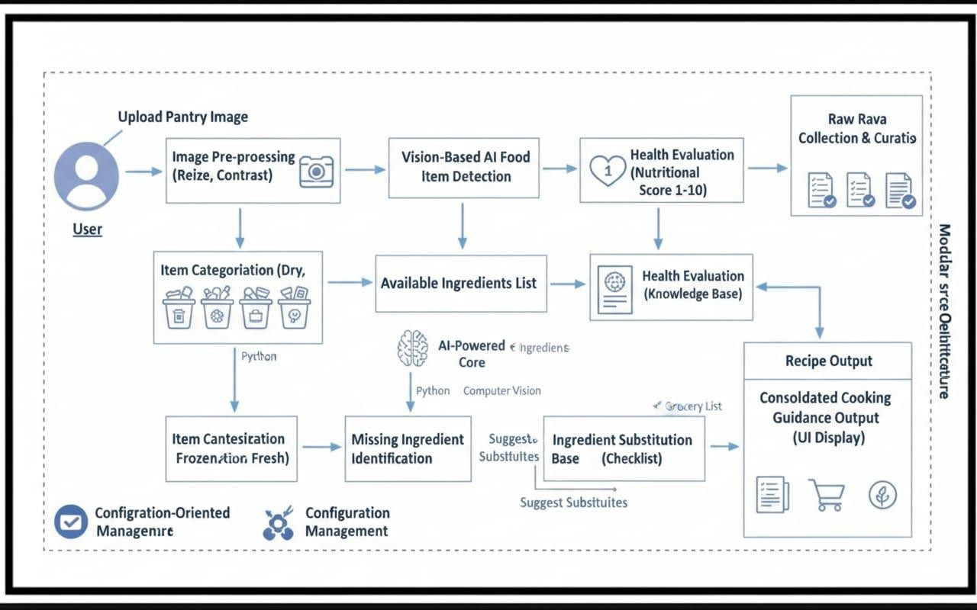

Pre-requisites

- Python 3.8+
Install Python from: https://www.python.org
- Streamlit Framework
- Documentation: https://docs.streamlit.io
- AI Provider Account (Optional)
Google AI Studio (Gemini API) or OpenAI Account for vision-based detection
https://aistudio.google.com
- Docker (Optional for Containerized Deployment)
https://www.docker.com
- Required Python Libraries
Refer to requirements.txt file included in the project
PROJECT WORKFLOW
MILESTONE 1: AI Vision Setup & Initialization
Activity 1.1: Set up AI Provider Access (Gemini / OpenAI Vision)
- Create or sign in to Google AI Studio or OpenAI account
- Generate API key for Vision API access
- Verify model availability and usage limits

Activity 1.2: Configure API Keys and Environment
- Create .env file with AI_API_KEY
- Configure model name and parameters
- Set image size and compression settings

Activity 1.3: Design and Fine-Tune Prompts
- Create prompts for pantry item detection
- Design prompts for recipe generation
- Create templates for substitution suggestions
- Develop prompts for health scoring explanations
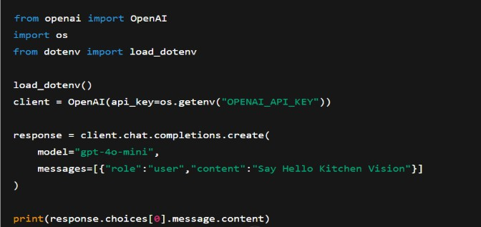
- Test prompts with sample pantry images

MILESTONE 2: Core Functionality Development Activity
Activity 2.1: Design Project Structure
- Create modular folder organization
- Separate UI, services, and utilities
- Define interfaces between modules

Activity 2.2: Implement Image Processing Module
- Image resizing and enhancement
- Compression and format conversion
- Byte stream preparation

Activity 2.3: Implement Vision Service
- Integrate AI-based image understanding
- Add mock detection mode
- Return structured ingredient list

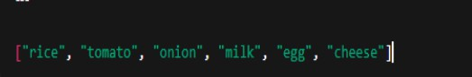

Activity 2.4: Implement Item Categorization
- Define storage category mappings
- Assign items to Dry, Cold, Frozen, Fresh

Activity 2.5: Implement Recipe Generation Service
- Generate three simple recipes
- Include ingredients, steps, time, difficulty
- Identify missing ingredients

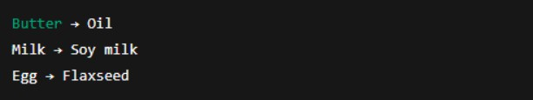

Activity 2.6: Implement Substitution Service
- Map missing items to substitutes
- Return substitution suggestions

Activity 2.7: Implement Health Evaluation Service
      - Calculate health score (1–10)
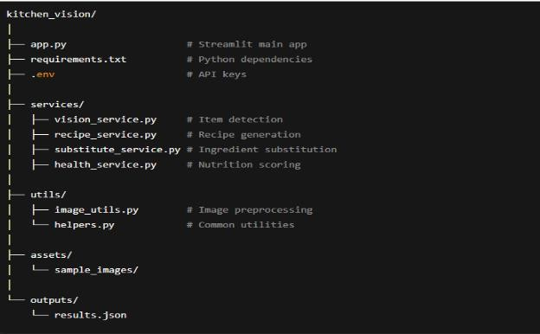
      - Generate explanation text

MILESTONE 3: Backend Implementation (Streamlit App)
Activity 3.1: Build Streamlit Interface Logic
- File uploader implementation
- Image preview
- Button triggers

Activity 3.2: Connect Services to UI
- Call vision service
- Call recipe service
- Call substitution service
- Call health service

Activity 3.3: Data Parsing s Validation

Validate AI outputs
- Handle empty results
- Standardize formats

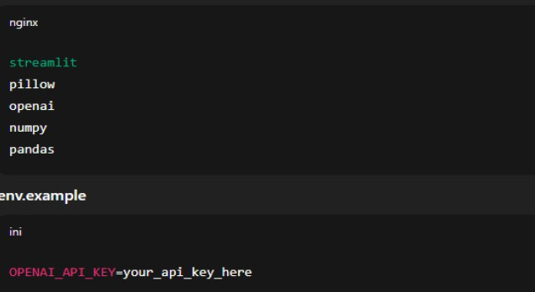

Activity 3.4: Error Handling s Logging
      - Try-except blocks
      - Friendly error messages
      - Debug logs

MILESTONE 4: UI Development
Activity 4.1: Build Streamlit Layout
- Title and description
- Upload section
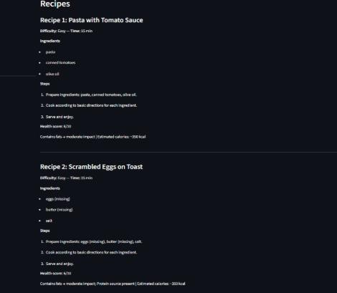
- Results sections

Activity 4.2: Display Results Dynamically
- Detected items list
- Categorized storage display
- Recipe cards
- Health score badges
- Grocery checklist
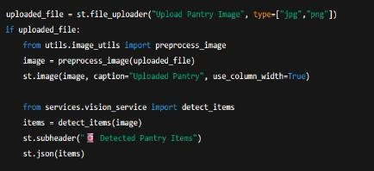

Activity 4.3: User Experience Enhancements
- Loading spinners
- Expandable sections
- Clear labels

MILESTONE 5: Testing & Optimization
Activity 5.1: Functional Testing
- Test with different pantry images
- Validate detection results
- Check recipe relevance
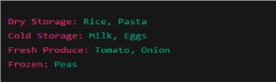

Activity 5.2: Evaluate AI Output Quality
- Ingredient accuracy
- Recipe practicality
- Substitute usefulness

Activity 5.3: Optimize Performance
- Reduce image size
- Cache results
- Improve prompt clarity

Activity 5.4: Deployment Preparation
- Create requirements.txt
- Add Dockerfile
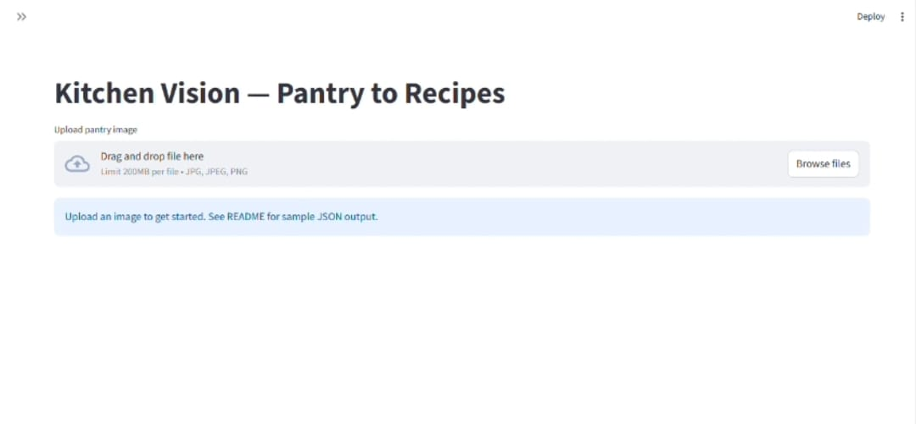
- Test locally and in container

Conclusion:
Kitchen Vision redefines everyday cooking assistance by delivering an intelligent, AI-powered solution that transforms pantry images into meaningful culinary insights. By combining Streamlit with advanced multimodal AI models, the system accurately analyzes pantry images, identifies and categorizes food items, and generates simple, practical recipes tailored to available ingredients.
From a modular backend architecture to seamless AI integration and an intuitive frontend, Kitchen Vision is built with a strong focus on usability, reliability, and performance. The application efficiently handles image processing, recipe generation, substitution logic, health scoring, and grocery list creation through well-structured service layers and reusable components.
Kitchen Vision not only helps users reduce food waste and save time but also promotes healthier eating habits by providing nutrition-based recipe ratings and balanced meal suggestions.

Through comprehensive testing and optimization, the system demonstrates stable performance, fast response times, and consistent output quality. Whether supporting busy individuals, students, or families, Kitchen Vision acts as a smart kitchen assistant that simplifies meal planning, enhances cooking confidence, and delivers personalized, data-driven culinary guidance—making every day cooking smarter, easier, and healthier.

